Internet and Internet Service Provider

1-Internet

🌐 What Is the Internet?
# Source: AI Source: Provided by: [Data Path: Persons Table -> ID Column: 1, Name_En Column: Motasem Essam] -> From: [ChatGPT] on [12/9/2025]
allallallallallallallallallThe Internet is a vast global network of interconnected computers and devices that communicate with each other using standardized protocols to share information, access services, and connect people around the world. It is essentially a “network of networks.”

🧠 In Simple Terms:
# Source: AI Source: Provided by: [Data Path: Persons Table -> ID Column: 1, Name_En Column: Motasem Essam] -> From: [ChatGPT] on [12/9/2025]
The Internet is like a massive web connecting millions (actually billions!) of computers, phones, servers, and other devices worldwide — allowing them to talk, share, and access data anytime, anywhere.

✅ Key Features of the Internet:
# Source: AI Source: Provided by: [Data Path: Persons Table -> ID Column: 1, Name_En Column: Motasem Essam] -> From: [ChatGPT] on [12/9/2025]
- allallallGlobal Connectivity: Connects millions of computers, devices, and networks worldwide.
- Decentralized: no single owner; many organizations manage parts of it
- Reliable Data Transmission: Uses protocols like TCP/IP to send and receive data reliably.
- Information Access: Provides instant access to websites, videos, articles, and more.
- Communication: Enables emails, chats, video calls, and social media.
- Services & Applications: Supports websites, email, banking, e-commerce, cloud storage, online gaming, and streaming.
- Resource Sharing: Allows sharing of files, printers, software, and other resources.

💡 Everyday Examples
# Source: AI Source: Provided by: [Data Path: Persons Table -> ID Column: 1, Name_En Column: Motasem Essam] -> From: [ChatGPT] on [12/9/2025]
- Browsing websites like Google or YouTube
- Sending emails or instant messages
- Streaming movies or music
- Online shopping or banking

🔧 How the Internet Works:
# Source: AI Source: Provided by: [Data Path: Persons Table -> ID Column: 1, Name_En Column: Motasem Essam] -> From: [ChatGPT] on [12/9/2025]
- Uses a system called TCP/IP (Transmission Control Protocol/Internet Protocol) to send and receive data.
- Data is broken into packets, sent through routers and servers, and reassembled at the destination.
- allallallDevices connect via wired (Ethernet) or wireless (Wi-Fi, mobile networks) connections.

allallall🖥️ Hardware Used for Networks & the Internet
# Source: AI Source: Provided by: [Data Path: Persons Table -> ID Column: 1, Name_En Column: Motasem Essam] -> From: [ChatGPT] on [12/9/2025]
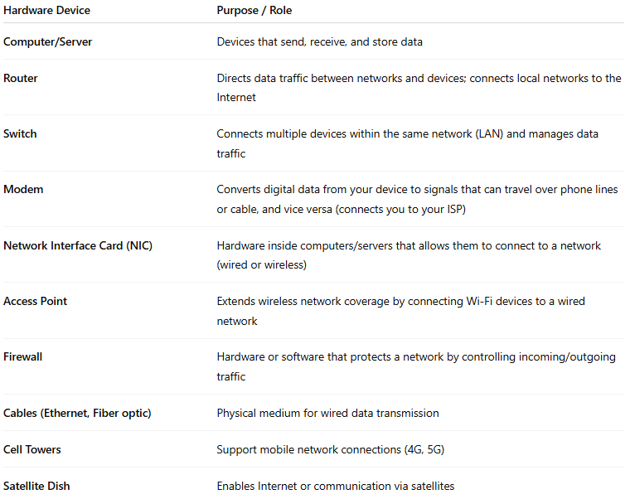
Hardware Device | Purpose / Role
Computer/Server | Devices that send, receive, and store data
Router | Directs data traffic between networks and devices; connects local networks to the internet
Switch | Connects multiple devices within the same network (LAN) and manages data traffic
Modem | Converts digital data from your device to signals that can travel over phone lines or cable, and vice versa (connects you to your ISP)
Network Interface Card (NIC) | Hardware inside computers/servers that allows them to connect to a network (wired or wireless)
Access Point | Extends wireless network coverage by connecting Wi-Fi devices to a wired network
Firewall | Hardware or software that protects a network by controlling incoming/outgoing traffic
Cables (Ethernet, Fiber optic) | Physical medium for wired data transmission
Cell Towers | Support mobile network connections (4G, 5G)
Satellite Dish | Enables internet or communication via satellites

✅ Basic Components of the Internet:
# Source: AI Source: Provided by: [Data Path: Persons Table -> ID Column: 1, Name_En Column: Motasem Essam] -> From: [ChatGPT] on [12/9/2025]
- Servers: Store websites, applications, and data.
- Clients: Devices like computers, smartphones, or tablets that access the Internet.
- Routers & Switches: Direct data packets to the correct destination.
- Internet Service Providers (ISPs): Companies that provide Internet access to homes, businesses, and devices.
- Protocols: Rules (like HTTP, HTTPS, FTP) that ensure data is transmitted correctly.

How It Fits Together
# Source: AI Source: Provided by: [Data Path: Persons Table -> ID Column: 1, Name_En Column: Motasem Essam] -> From: [ChatGPT] on [12/9/2025]
- Your computer connects to a router (via cable or Wi-Fi).
The router directs traffic to the modem, which connects to your ISP (Internet Service Provider).
- allallallThe ISP connects to the broader internet backbone, made up of massive routers and fiber networks.

Summary:
# Source: AI Source: Provided by: [Data Path: Persons Table -> ID Column: 1, Name_En Column: Motasem Essam] -> From: [ChatGPT] on [12/9/2025]
allallallThe Internet is a worldwide network that allows computers and devices to communicate, share information, and access services. It connects millions of people and devices, making communication, learning, business, and entertainment possible at a global scale.

2-Internet Service Provider

🌐 What Is an Internet Service Provider (ISP)?
# Source: AI Source: Provided by: [Data Path: Persons Table -> ID Column: 1, Name_En Column: Motasem Essam] -> From: [ChatGPT] on [12/9/2025]
allallallAn Internet Service Provider (ISP) is a company or organization that provides individuals, businesses, and other entities access to the Internet. Essentially, they act as the gateway that connects your device or network to the global Internet.

🧠 In Simple Terms:
# Source: AI Source: Provided by: [Data Path: Persons Table -> ID Column: 1, Name_En Column: Motasem Essam] -> From: [ChatGPT] on [12/9/2025].
An ISP is a company or organization that provides you access to the internet.

What Does an ISP Do?
# Source: AI Source: Provided by: [Data Path: Persons Table -> ID Column: 1, Name_En Column: Motasem Essam] -> From: [ChatGPT] on [12/9/2025]
- Connects your home, office, or device to the internet.
- Offers services like:
  - wired Broadband internet (cable, DSL, fiber)
  - wireless Mobile data (3G, 4G, 5G)
  - Email accounts and Services: Offers email accounts and hosting.
  - Web hosting: Hosts websites and online services.
- allallallManages the network infrastructure to route your internet traffic.
- Provides customer support and sometimes domain registration.
  - Customer Support: Helps users with connection issues, billing, and setup.
  - Domain Registration: Some ISPs allow domain name registration for websites.

Examples of ISPs
# Source: AI Source: Provided by: [Data Path: Persons Table -> ID Column: 1, Name_En Column: Motasem Essam] -> From: [ChatGPT] on [12/9/2025]
- Comcast
- AT&T
- Verizon
- Spectrum
- Vodafone

How It Works:
# Source: AI Source: Provided by: [Data Path: Persons Table -> ID Column: 1, Name_En Column: Motasem Essam] -> From: [ChatGPT] on [12/9/2025]
- Your device connects to an ISP (via modem/router).
- ISP connects to the global internet backbone.
- You can then access websites, send emails, stream videos, etc.

📶 Types of ISPs:
# Source: AI Source: Provided by: [Data Path: Persons Table -> ID Column: 1, Name_En Column: Motasem Essam] -> From: [ChatGPT] on [12/9/2025]
- Dial-up ISPs: Older technology using phone lines (rarely used now).
- Broadband ISPs: High-speed wired connections like DSL, cable, or fiber optics.
- allallallWireless ISPs: Provide internet over Wi-Fi or mobile networks (3G, 4G, 5G).
- Satellite ISPs: Provide internet via satellites, useful in remote areas.

Summary:
# Source: AI Source: Provided by: [Data Path: Persons Table -> ID Column: 1, Name_En Column: Motasem Essam] -> From: [ChatGPT] on [12/9/2025]
An ISP is a company that provides you with access to the Internet, along with additional services like email, web hosting, and technical support. Without an ISP, your devices cannot connect to the Internet or communicate online.

